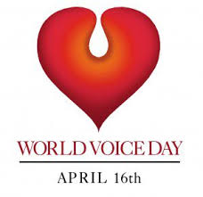
Invitation
We would like to invite everyone who is interested, to our department’s concert, which is being held on the occasion of World Voice Day (WVD)

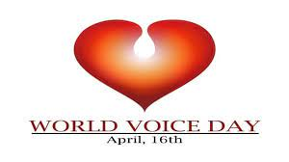

Since 1999, World Voice Day has been an annual worldwide celebration on 16 April to raise awareness of the importance of the Human Voice. It is a celebration of the singing voice, which is the most important tool of communication for us, after the voice itself. The Department of Singing of the DE ZK would therefore like to join this international event with a concert on 16 April 2024 at 18.00

Location:
University of Debrecen, Faculty of Music
Liszt Hall
4032 Debrecen, Nagyerdei krt.82
Date:
Tuesday, 16.04 .2024, 8.00
On the programme:
Selections from Mozart's The Magic Flute
(Hungarian translation by Csokonai Vitéz Mihály),
Bizet's Carmen and works by Wagner
Performers:
The Students of the Faculty of Music of the University of Debrecen
Lecturers and guests of the Department of Music of Debrecen Music
Opening Speech: Dr. Krisztina Mészáros Ear, Nose and Throat specialist, Phoniatrist
Detailed Programme:
Mozart: Magic Flute:
Sarastro aria:
László Erdély

Pamina aria:
Kövér Aida

Mozart and Csokonai:
Monostatos - Pamina – Papageno:
Illi Ráhel - Bálint Krúdy - Mihály Lévai

Pamína -Papageno:
Illi Ráhel - Mihály Lévai

From the opera Carmen by G. Bizet:
Carmen aria - Habanera
Tóth Vera

Card tercet - "Melon, coupons... En vain pour éviter...:
Hajnalka Pálos, Réka Gacs, Vera Tóth

Michaela's aria - "C'est des contrebandiers...:
Je dis que rien ne m'épouvante"
Faluvégi Fanni

Csempész-kvintett - "Nous avons en tête une affaire"
Pauk Eleonóra, Pető Dóra, Tóth Vera,
Krúdy Bálint, Baranyi Gyula

Selection of works by R. Wagner
Wesendonck songs: "Im Treibhaus"
Anna Nyárádi

Tannhäuser: Csarnokária
Stula Ana
Parsifal: Scene of the flower girls :
I.Faluvégi Fanni, Stula Ana, Nyárádi Anna
Fanni Nzala II, Aida Kövér, Réka Kriszta
Choir:
Pauk Eleonóra, Buka Bogi, Wang Xinchun,
Pálos Hajnalka, Illi Ráhel, Nagy Laura,
Kerekes Anna, Pető Dóra

Die Walküre: The March of the Valkyries
Faluvégi Fanni, Tarnócz Daisy, Kövér Aida,
Tóth Vera, Stula Ana, Nyárádi Anna, Gacs Réka,
Kriszta Réka
With the participation of:
On piano:
Boda Balázs, Böszörményi Judit, Cs.Nagy Ildikó
, Kozma Dávid
DE ZK Brass and percussion ensemble
Gábor Kustár Artist

