# "Protect Your Little Voice, for a More Melodious Future" - The Third Xiangya Hospital of Central South University Visited Bocai Primary School in Yuelu District for the 2025 "World Voice Day" Event

On April 11, 2025, Zou Mi, the deputy secretary of the Communist Party branch of the Spinal Surgery & Rehabilitation Medicine Department of the Fifth General Party Branch of the Third Xiangya Hospital of Central South University, Peng Jing, a chief Speech - Language Pathologist of the Rehabilitation Medicine Department, and Xie Ruidong, a nurse from the Department of Otorhinolaryngology - Head and Neck Surgery, entered the campus and carried out a unique health - science popularization activity titled "Protect Your Little Voice, for a More Melodious Future", safeguarding the vocal health of children.

On the day of the event, the medical staff of the Third Xiangya Hospital of Central South University, with their professional medical knowledge and rich clinical experience, carefully prepared a series of science - popularization sessions for the children. In the knowledge lecture, Peng Jing, the chief Speech - Language Pathologist of the Rehabilitation Medicine Department, used vivid and interesting language to explain the formation mechanism of the voice, common vocal problems, and how to protect the throat in daily life in an easy - to - understand way. The children listened with great interest, their bright eyes filled with a thirst for knowledge, and the atmosphere at the scene was enthusiastic.

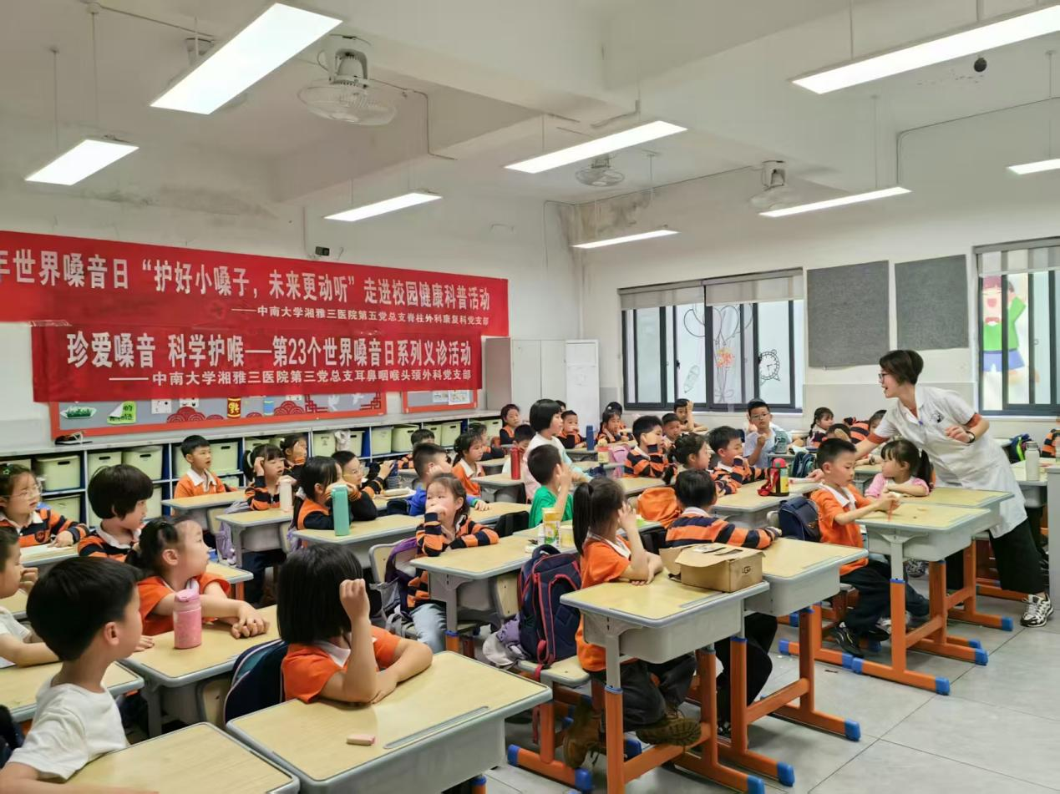

PICTURE 1 Peng Jing on-site explains scientific voice care knowledge and asks questions

In addition to the theoretical explanations, the event also included a practical teaching session. Breathing is closely related to vocalization. Zou Mi, the deputy secretary of the Communist branch of the Spinal Surgery & Rehabilitation Medicine Department, demonstrated the correct breathing techniques in person, allowing the children to master scientific breathing methods through imitation and practice. The children imitated seriously and communicated with each other while learning.

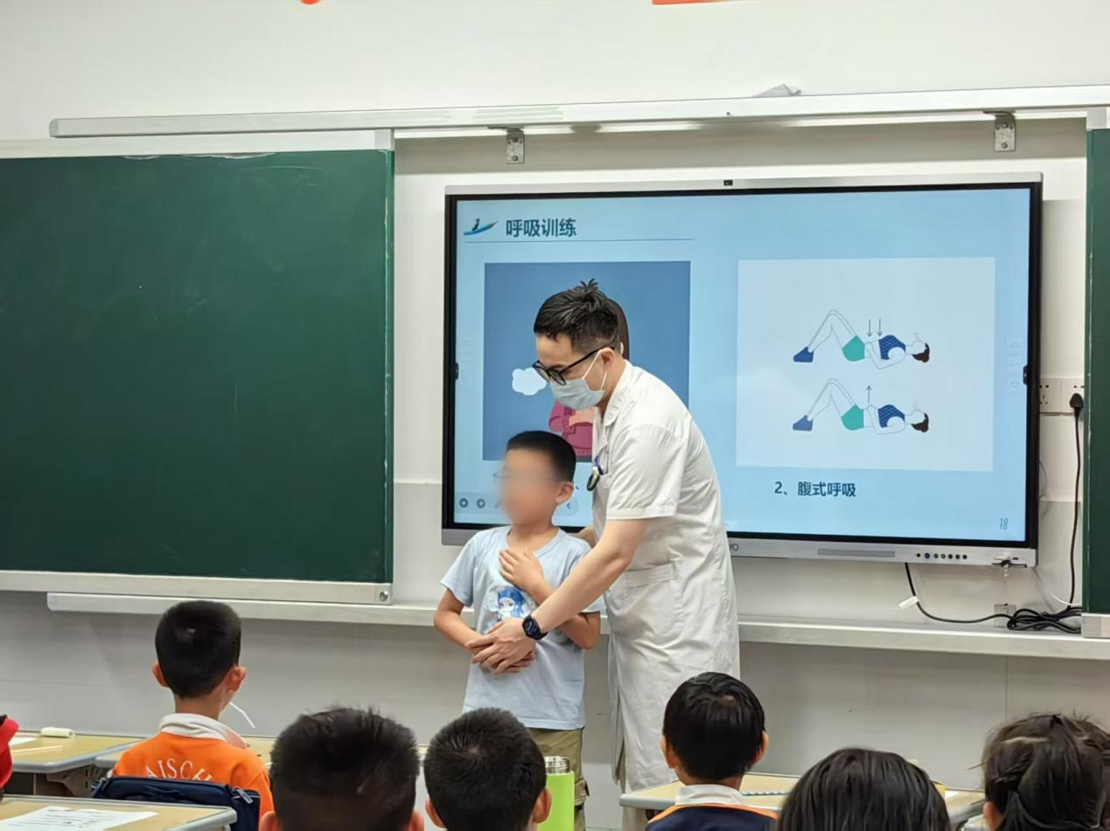

PICTURE 2 Zou Mi, is on-site to guide children in breathing exercises.

Furthermore, Xie Ruidong, the nurse from the Department of Otorhinolaryngology - Head and Neck Surgery, carefully guided the children to sign the "My Voice - Protecting Pact". The children expressed their determination to protect their voices scientifically from then on and avoid bad vocal habits.

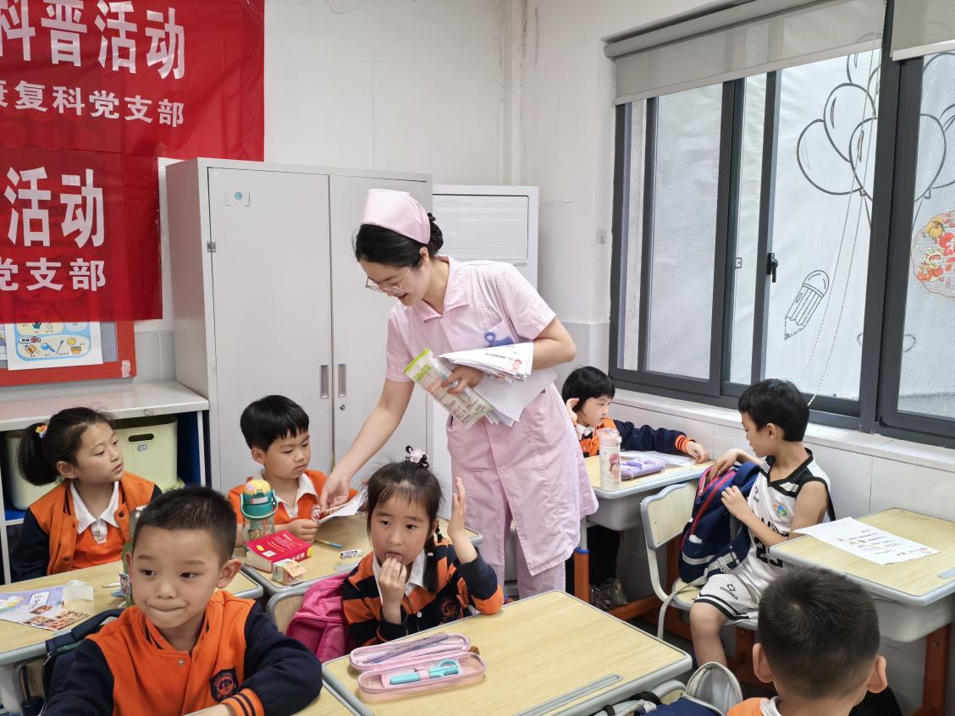

PICTURE 3 Xie Ruidong conscientiously guided the children to sign "My Voice Protection Charter"

This action by the Party branch of the Spinal Surgery Rehabilitation Department of the Fifth General Party Branch and the Party branch of the Department of Otorhinolaryngology - Head and Neck Surgery of the Third General Party Branch of the Third Xiangya Hospital of Central South University is a vivid manifestation of the hospital's fulfillment of its social responsibility and promotion of health - knowledge popularization. In the future, the hospital will continue to carry out such science - popularization activities to expand the scope of health - knowledge dissemination. It is hoped that with the joint efforts of all sectors of society, every child can protect their little voices and have a more melodious future.

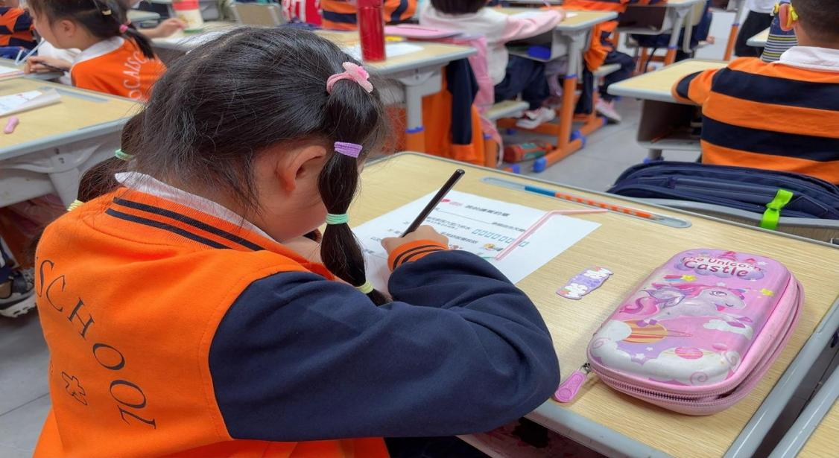

PICTURE 4 The children earnestly signed "My Voice Protection Charter"